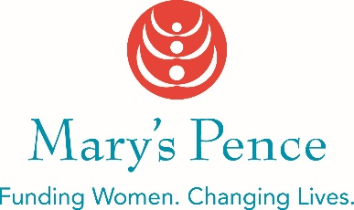

MARY’S PENCE
INITIAL FUNDING INQUIRY
Please type or print. Date:_______________

Organization name

Organization website
City, State where work takes place

Organizational budget (Limit $250,000)
Name, title, email, and phone number of contact person

What is the need or problem in your community you are addressing? (Suggested word count 100)

Describe the work for which you are seeking funding. (Suggested word count 150)

What is the systemic impact on the community of the work described above? (Suggested word count 100)

Please email this completed form to Grace Gbolo at gracegbolo@maryspence.org. We will contact you with information on next steps once we have reviewed your funding inquiry.

