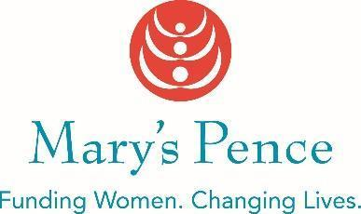

2021 - 2022 MARY’S PENCE GRANT APPLICATION

PART I: Organization Information |  |  |  |  |  | Date
Organization to be Funded |  |  |  |  |  | Age of Organization  ☐ Startup  ☐ 1-3 years  ☐ More than 3 years
Address |  | City, State |  | Zip Code
Name, Title and Pronouns of Contact Person

Phone |  |  | Email
FaceBook page:  Instagram page:  Twitter handle: |  |  | Website
Do you have 501c3 tax status? No ☐ Yes ☐ If yes, provide your #EIN:
Does your organization have a fiscal sponsor? If yes, please provide the contact information for your fiscal sponsor (name, address, phone, and email). We will ask for a copy of your agreement if you receive a grant.

Organizational Budget $  (Maximum $200,000) | Project Name and Budget (if applicable) $ |  |  |  | Amount Requested $  (Maximum $5,000)
Has the organization received a grant from Mary’s Pence in the past? Yes ☐ No ☐
If yes, indicate each year funded and amount: ____________________ ______________________

If you are a new applicant, how did you learn of Mary’s Pence Grants?

Who will be the contact person for grant activities? Please include name, pronouns, title, email, and phone if different from the person completing the grant application as listed above.

Please list any local press in your organization’s area. Mary’s Pence will contact the media if your funding is approved.

PART II: Background

- Tell us about your organization (answer each item separately, this section should be one page maximum).
- Organization Mission
- Population impacted including demographics
- Does your work focus solely on women* or gender issues? And if not, is there an aspect of your work framed around issues affecting women?
- Board - size and demographics
- Key staff and volunteer - size and demographics

*Women includes cis women, trans women, and/or non-binary people.

PART III: Work to be Funded

- Please describe the work to be funded (answer each item separately, this section should be two pages maximum)
- What is the need?
- What are the outcomes you want to attain? And how will you know you are successful?
- How will you go about achieving this outcome?
- How does the work create long term systemic change (refer to list in grants criteria)?
- How was the community involved in initiating this work and how do they participate ongoing?
- Do you have community partners involved in accomplishing this work? Who are they and what is their role?

Part IV: Budget

- Attach a one page copy of your organization operating budget. Indicate how many employees are covered in the salary line, how many are cis women, trans women, or nonbinary, and what positions they hold. Include both income and expenses.

- If you are requesting funding for a specific project, attach an additional one page itemized budget summary for the project.

APPLICATION INFORMATION

PLEASE SEND YOUR APPLICATION BY EMAIL OR HARD COPY TO:
Mary’s Pence, 275 East 4th Street #642, St. Paul, MN 55101
E-mail: gracegbolo@maryspence.org

If you have questions please contact us at 651-788-9869.

