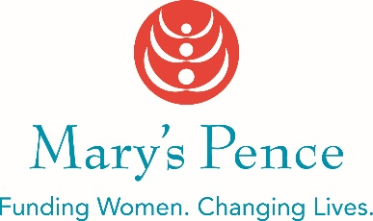

2020 - 2021 MARY’S PENCE FUNDING INQUIRY
Please type or print.

Organization name

City, State and Country Where Project Takes Place

Name, Title, Email, and Phone Number of Contact Person

What is your organization/group's mission?

Describe the need or issue you are planning to address. (Suggested word count 100)

Describe the proposed project. (Suggested word count 150)

Please email this completed form to Robyn Browning at robyn@maryspence.org. We will contact you with information on next steps once we have reviewed your funding inquiry.

